Boundary in Solid Geometry
# Source: AI Source: Provided by: [Data Path: Persons Table -> ID Column: 1, Name_En Column: Motasem Essam] -> From: [ChatGPT] on [7/25/2026]
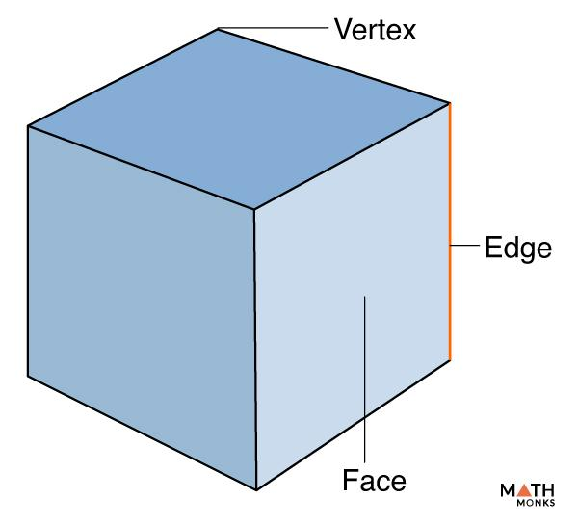
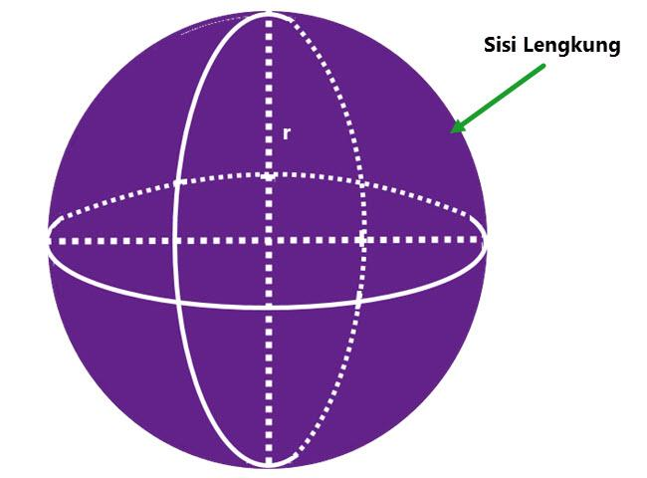
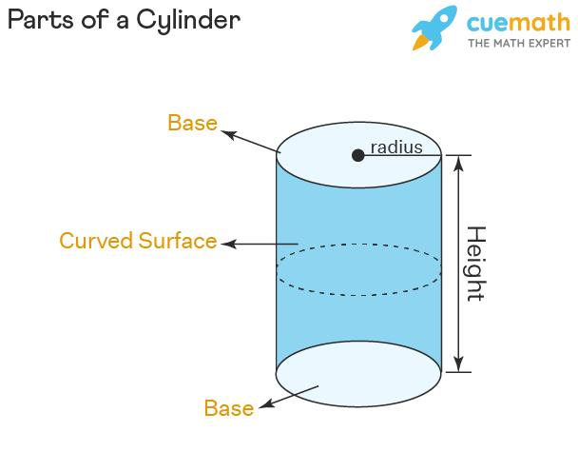

Definition
# Source: AI Source: Provided by: [Data Path: Persons Table -> ID Column: 1, Name_En Column: Motasem Essam] -> From: [ChatGPT] on [7/25/2026]
A boundary in Solid Geometry is the collection of points, surfaces, edges, or other geometric elements that separate a solid or three-dimensional region from its exterior.
The boundary defines the outer limits of a solid. Depending on the type of solid, it may consist of flat faces, curved surfaces, or a combination of both.
For example, the boundary of a cube consists of its six square faces, including their edges and vertices.

Simple Definition
# Source: AI Source: Provided by: [Data Path: Persons Table -> ID Column: 1, Name_En Column: Motasem Essam] -> From: [ChatGPT] on [7/25/2026]
A boundary is the outer limit that separates a solid from the space outside it.
For example, the outer surface of a sphere forms the boundary of the ball-shaped region it encloses.

Key Characteristics
# Source: AI Source: Provided by: [Data Path: Persons Table -> ID Column: 1, Name_En Column: Motasem Essam] -> From: [ChatGPT] on [7/25/2026]
- Separating role: A boundary separates a solid region from its exterior.
- Outer limit: It determines the extent of a geometric object or region.
- Surface structure: The boundary of a three-dimensional solid is generally a two-dimensional surface, possibly made of several pieces.
- Different shapes: Boundaries may be flat, curved, or composed of both.
- Closedness: A solid region that includes its boundary is called a closed region in the usual mathematical setting.
- No thickness: An ideal geometric boundary surface has no thickness.

Types of Boundaries in Solid Geometry

1. Polyhedral Boundary
# Source: AI Source: Provided by: [Data Path: Persons Table -> ID Column: 1, Name_En Column: Motasem Essam] -> From: [ChatGPT] on [7/25/2026]
A boundary composed of flat polygonal faces joined along edges.
Examples: Cubes, cuboids, prisms, and pyramids.
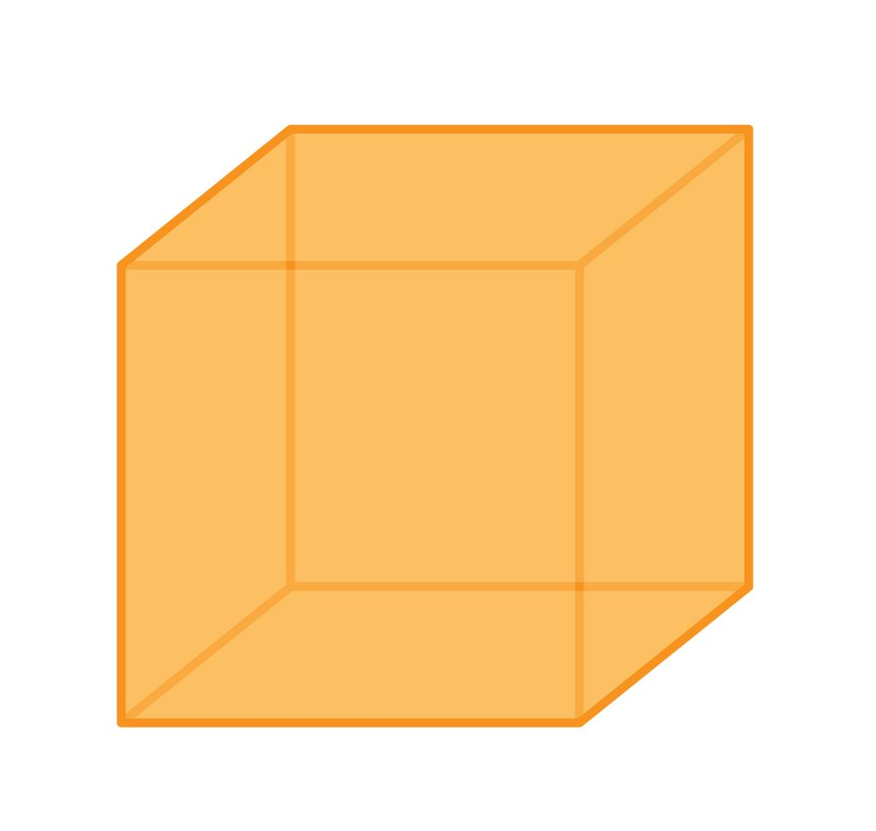

2. Curved Boundary
# Source: AI Source: Provided by: [Data Path: Persons Table -> ID Column: 1, Name_En Column: Motasem Essam] -> From: [ChatGPT] on [7/25/2026]
A boundary that includes curved surfaces rather than only flat polygonal faces.
Examples: The spherical boundary of a ball-shaped region and the curved lateral surface of a cylinder.
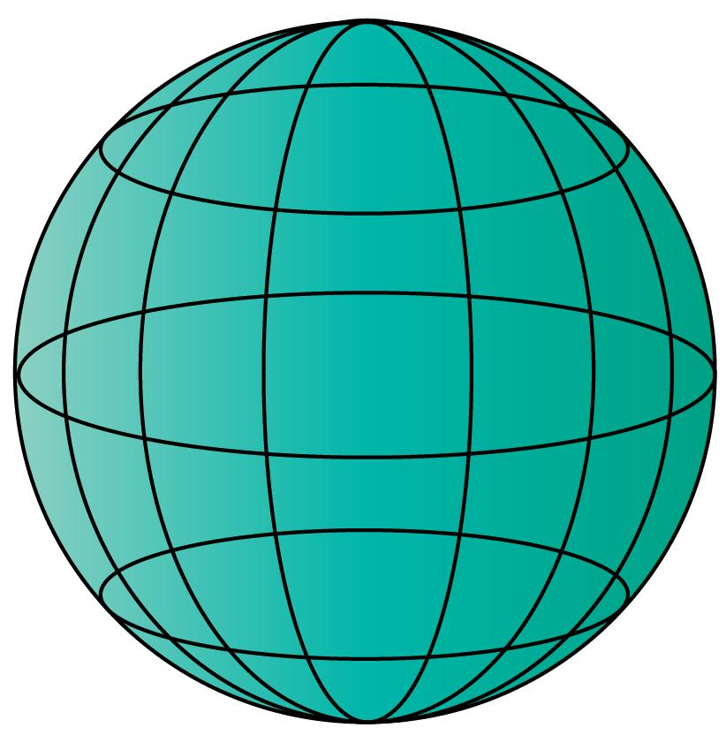

3. Composite Boundary
# Source: AI Source: Provided by: [Data Path: Persons Table -> ID Column: 1, Name_En Column: Motasem Essam] -> From: [ChatGPT] on [7/25/2026]
A boundary made from different surface types or geometric pieces.
Examples: A solid formed by combining a cylinder and a cuboid, where the exposed boundary includes both flat and curved surfaces.


4. Boundary Between Interior and Exterior
# Source: AI Source: Provided by: [Data Path: Persons Table -> ID Column: 1, Name_En Column: Motasem Essam] -> From: [ChatGPT] on [7/25/2026]
The boundary is the set of points separating the points inside a region from those outside it.
Example: The spherical surface separates the interior of a ball from the surrounding space.
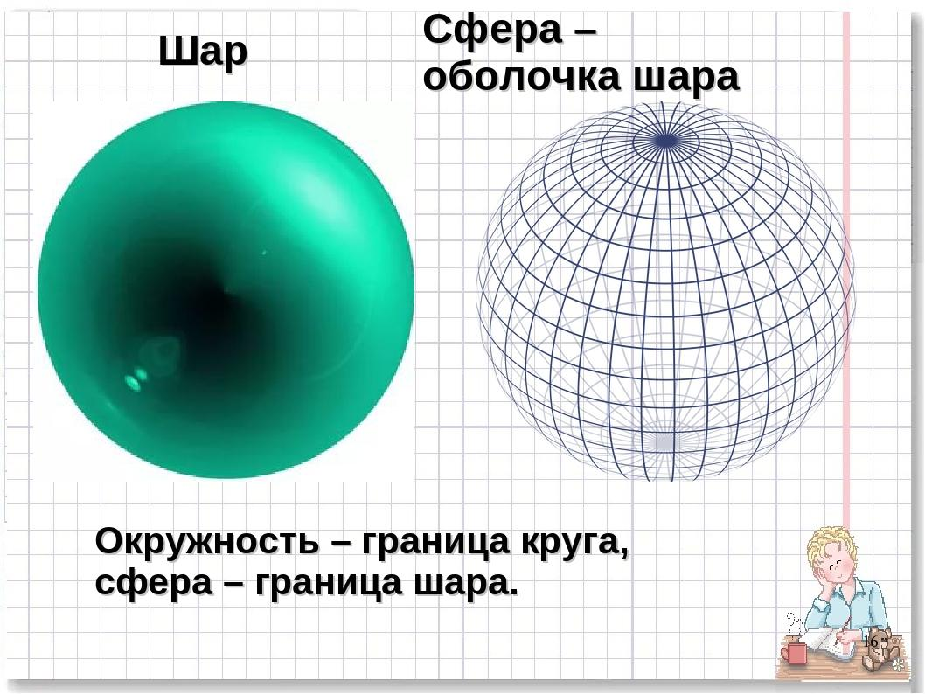

Boundaries of Common Solids
# Source: AI Source: Provided by: [Data Path: Persons Table -> ID Column: 1, Name_En Column: Motasem Essam] -> From: [ChatGPT] on [7/25/2026]
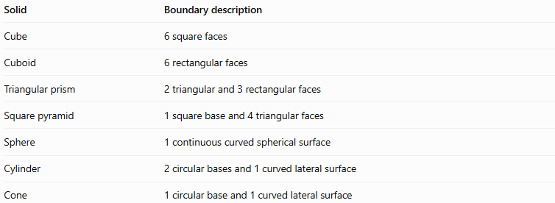
Solid | Boundary description
Cube | 6 square faces
Cuboid | 6 rectangular faces
Triangular prism | 2 triangular and 3 rectangular faces
Square pyramid | 1 square base and 4 triangular faces
Sphere | 1 continuous curved spherical surface
Cylinder | 2 circular bases and 1 curved lateral surface
Cone | 1 circular base and 1 curved lateral surface
These descriptions refer to the boundary surfaces. Where surfaces meet, their shared edges and vertices are also part of the boundary of the solid.

Fundamental Properties

1. Boundary, Interior, and Exterior
# Source: AI Source: Provided by: [Data Path: Persons Table -> ID Column: 1, Name_En Column: Motasem Essam] -> From: [ChatGPT] on [7/25/2026]
A solid region can be understood using three related concepts:
- Interior: Points lying inside the region, not on its boundary.
- Boundary: Points separating the interior from the exterior.
- Exterior: Points outside the region, not on its boundary.
For a closed ball, the boundary is its spherical surface; the interior is the space strictly inside that surface.

2. Boundary and Surface Area
# Source: AI Source: Provided by: [Data Path: Persons Table -> ID Column: 1, Name_En Column: Motasem Essam] -> From: [ChatGPT] on [7/25/2026]
The boundary describes the outer limit, while surface area measures the total area of the boundary surfaces.
For a cube of side length $a$,
$$\boxed{S=6a^{2}}$$
For a sphere of radius $r$,
$$\boxed{S=4πr^{2}}$$
These formulas measure surface area, not the volume enclosed by the boundary.

3. Boundary and Volume
# Source: AI Source: Provided by: [Data Path: Persons Table -> ID Column: 1, Name_En Column: Motasem Essam] -> From: [ChatGPT] on [7/25/2026]
The boundary encloses or delimits a three-dimensional region. Volume measures the amount of three-dimensional space occupied by that region.
For a cube,
$$V=a^{3}$$
For a sphere,
$$V=\frac{4}{3}πr^{3}$$
A boundary and the region it encloses are related but are not the same geometric object.

4. Closed and Open Regions
# Source: AI Source: Provided by: [Data Path: Persons Table -> ID Column: 1, Name_En Column: Motasem Essam] -> From: [ChatGPT] on [7/25/2026]
A closed solid region includes its boundary. A corresponding open region excludes its boundary.
For example, the closed ball of radius $r$, centered at the origin, is
$$x^{2}+y^{2}+z^{2}≤r^{2}$$
Its interior, excluding the boundary, is
$$x^{2}+y^{2}+z^{2}<r^{2}$$
The boundary itself satisfies
$$x^{2}+y^{2}+z^{2}=r^{2}$$

Boundary vs. Face vs. Surface vs. Region
# Source: AI Source: Provided by: [Data Path: Persons Table -> ID Column: 1, Name_En Column: Motasem Essam] -> From: [ChatGPT] on [7/25/2026]
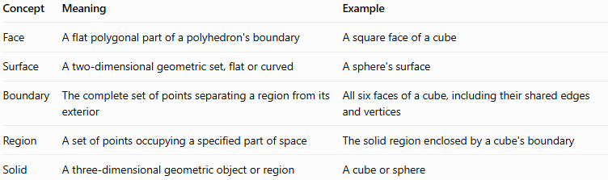
Concept | Meaning | Example
Face | A flat polygonal part of a polyhedron's boundary | A square face of a cube
Surface | A two-dimensional geometric set, flat or curved | A sphere's surface
Boundary | The complete set of points separating a region from its exterior | All six faces of a cube, including their shared edges and vertices
Region | A set of points occupying a specified part of space | The solid region enclosed by a cube's boundary
Solid | A three-dimensional geometric object or region | A cube or sphere
Important distinction: In ordinary geometry, solid and region are sometimes used interchangeably. In more precise mathematical language, a region is a set of points, while its boundary is the set separating it from the rest of space.

Applications
# Source: AI Source: Provided by: [Data Path: Persons Table -> ID Column: 1, Name_En Column: Motasem Essam] -> From: [ChatGPT] on [7/25/2026]
- Geometry: Defining the limits and shape of three-dimensional regions.
- Architecture: Identifying the exterior surfaces of buildings and structures.
- Engineering: Determining the outer surfaces of components.
- Computer graphics: Defining the surfaces that represent 3D objects.
- Manufacturing: Calculating surface area and planning coatings or materials.
- Mathematics: Studying interior, exterior, open sets, closed sets, and geometric regions.

Key Points
# Source: AI Source: Provided by: [Data Path: Persons Table -> ID Column: 1, Name_En Column: Motasem Essam] -> From: [ChatGPT] on [7/25/2026]
- A boundary separates a region from its exterior.
- The boundary of a polyhedron is made of polygonal faces and includes their edges and vertices.
- Curved solids have boundaries containing curved surfaces.
- A boundary is not the same as the region it encloses.
- Surface area measures the area of the boundary surfaces.
- Volume measures the three-dimensional space occupied by a solid region.
- A closed region includes its boundary, while an open region excludes it.

Conclusion
# Source: AI Source: Provided by: [Data Path: Persons Table -> ID Column: 1, Name_En Column: Motasem Essam] -> From: [ChatGPT] on [7/25/2026]
A boundary in Solid Geometry defines the outer limit of a three-dimensional region and separates its interior from the surrounding exterior. It may consist of flat faces, curved surfaces, or a combination of both. Understanding boundaries helps distinguish a solid from its surface, calculate surface area, describe geometric regions, and analyze three-dimensional shapes.

